* Extract the zip file by right clicking on it then click on the extract here… option

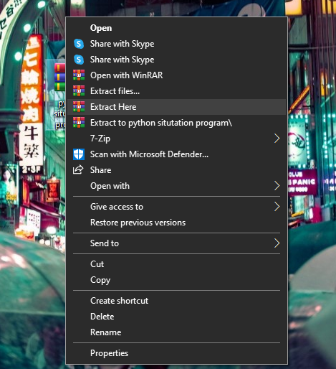

* Open the the “main” folder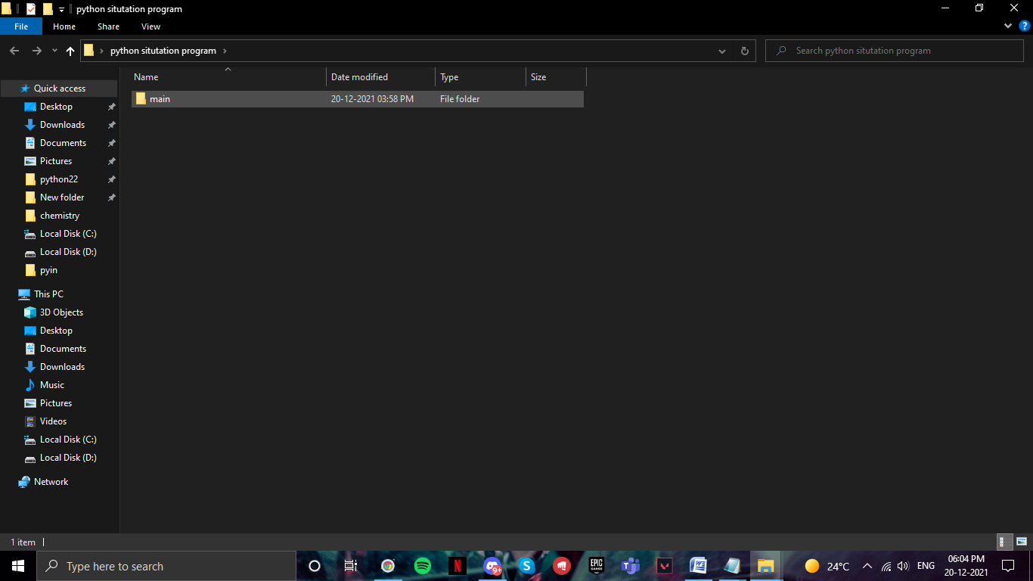
* Then the open the “main” icon

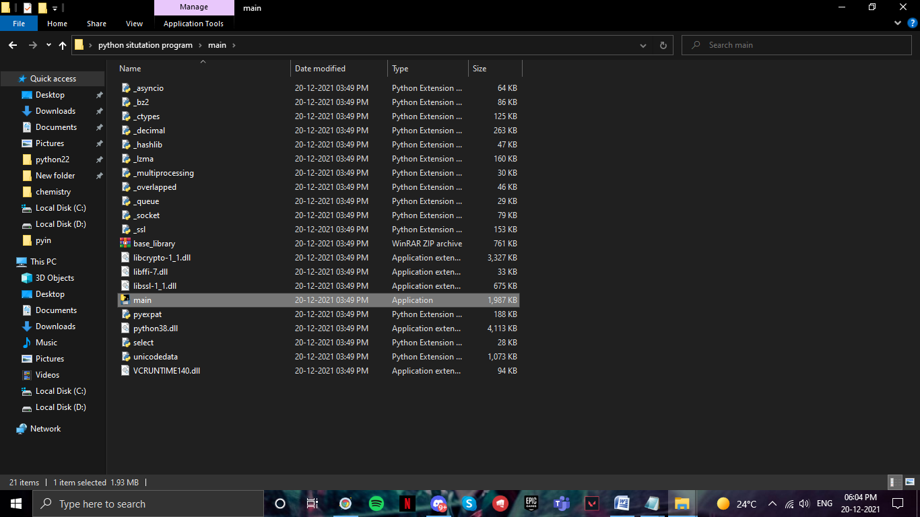

* Now play and the game and enjoy

